Reliability test and improvement of a sensor system for object detection

Master of Engineering
Information Technology
Deblina Karmakar Indranil Saha
1427365 1427190
deblina.karmakar@stud.fra-uas.de, indranil.saha@stud.fra-uas.de

Abstract—This study focuses on the reliability testing and enhancement of a FIUS sensor system designed for different object detection. An evaluation and improvement goal are set for the current measuring system, which is essential for detecting echo in a pulsed ultrasonic beam. The study addresses challenges related to reliability, error propagation, and modeling signal behavior. Our project uses sophisticated mathematical models and machine learning techniques to improve ultrasonic signal modelling using a FIUS system with a transducer and Red Pitaya microcontroller. Through several dependability testing, the research attempts to pinpoint shortcomings and difficulties in the existing system and contributes to the optimization of sensor systems where object detection is concerned.
Keywords—FIUS sensor, Red Pitaya, Machine Learning, Object detection

Introduction
In the realm of autonomous vehicles navigating urban landscapes, there is a significant difficulty in identifying objects from people, especially when it comes to identifying soft from hard objects. Making this vital distinction is important for ensuring that autonomous vehicles can navigate safely and successfully requires The difficulty of this task arises from the need to accurately recognise and react to a wide range of items, each having unique physical characteristic. A key element in ultrasonic applications, echo detection plays a major role in tackling this problem and has broad ramifications in a variety of fields. The fundamental ideas behind ultrasonic echo detection, which are crucial for avoiding obstacles and measuring distance, have influenced developments in a number of sectors, including industrial automation, robotics, and navigation systems. The purpose of this research is to better understand the complexities of echo detection in order to aid in the advancement of technologies that improve the effectiveness and safety of autonomous cars in urban settings.
The main goals of our suggested system is construction of a reliable test for echo detection and the enhancement of the sensor system in conjunction with machine learning techniques.

Ease of Use

Measuring Equipments
The main tools utilised to carry out this study will be covered in this section.
The measurement apparatus that makes up our FIUS sensor is a close integration of three primary parts:
1. Ultrasonic Sensor SRF02 with a mean frequency of 40 kHz and a power output of 150 mW (manufacturer's data) for sensing.

Fig. 1. Hardware of FIUS sensor
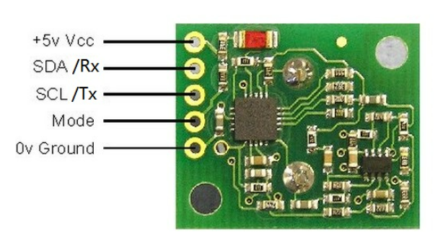
Fig. 2: Pin function of SRF02 ultrasonic sensor

2. Embedded System Red Pitaya with a sampling frequency of 1.95 MS/s and a resolution of 14 bit for analog to digital conversation of received signal.

Fig. 3: Interface between Embedded System and Sensor
3. Laptop with UDP_Client Application

Fig. 4: UDP client view on laptop

Measuring Methods
The study has been executed using the experimental setup provided in the Robolab of Frankfurt University of applied sciences.
Over a long, black metal platform, the FIUS sensor is fixed to the top. The measurement object is set up on a white, short stand directly in front of the FIUS sensor.
- Detection of Hard object:
To do this, we used a measuring scale to place a hard box beneath the sensor at a distance of 1 metre and 15 centimetres. We collected 1000 ADC data five times, noting the difference between the manually measured distances and those displayed on the UDP_client application. The manufacturer's data indicates that the Ultrasonic Sensor SRF02 has a mean frequency of 40 kHz and a power output of 150 mW for sensing.
Fig. 5: Snap of Hard object setup
- Detection of Soft object (Human):
Using a measuring scale, a human stood beneath the sensor at a distance of one metre and fifteen centimetres. We collected 1000 ADC data five times, noting the difference between the manually measured distances and those displayed on the UDP_client application.
Fig. 6: Snap of Hard object setup

Literature review on ultrasonic distance measurement
With its rich history and ongoing progress, ultrasonic distance measurement is a dynamic area which has undergone significant growth over the years, with current advances in signal processing and integration with other sensor technologies making it a vital tool in a variety of applications, promising further advancements in accuracy, reliability, and versatility.

Some of distance measurement methods using ultrasonic sensors are discussed below:

1.Time-of-Flight principle:
The Time-of-Flight principle (ToF) is a method for measuring the distance between a sensor and an object, based on the time difference between the emission of a signal and its return to the sensor, after being reflected by an object. Various types of signals (also called carriers) can be used with the Time-of-Flight principle, the most common being sound and light [1].

2.Ultrasonic Pulse-Echo methods:
The pulse-echo method uses an ultrasonic pulsed. Ultrasonic waves are mechanical vibrations and have a frequency greater than 20 000 Hz. Depending of the velocity of sound in a material and the frequency, the wavelength can be calculated:
λ=c/f
λ: wavelength [m], c: velocity of sound [m/s] and f: frequency [Hz].
An ultrasonic pulsed wave is a synthesis of sinusoidal waves with different frequencies and amplitudes [2].
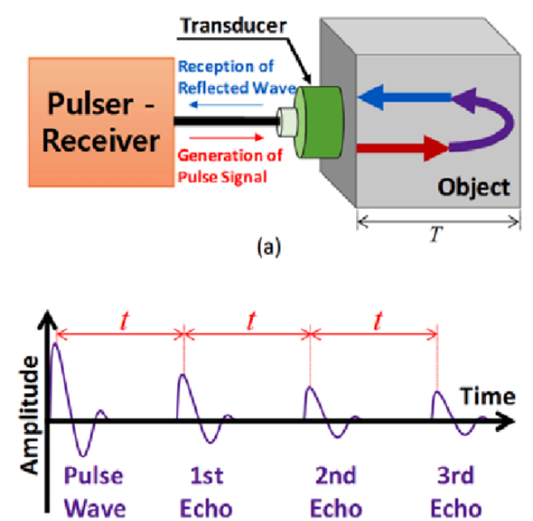

Fig.7: (a) pulse-echo method and (b) a received pulse-echo signal for the object [3]
3. Frequency Modulation Continuous Wave (FMCW):
It is a special type of radar system that measures both distance and velocity of moving objects. This is achieved by continuously varying the frequency of the transmitted signal by a modulating signal at a known rate over a fixed time period. A variety of frequency modulation techniques, such as sawtooth modulation, triangular modulation, sine wave modulation can be used to change the frequency pattern of the emitted radio wave [4].
4.Triangulation Methods:
It involves triangulating the distance to an object by using several ultrasonic sensors positioned at specified angles and distances from the target. It is Frequently utilised in positioning systems and mobile robotics.

ML method used for finding first reflection
In machine learning (ML), finding the initial reflection usually entails using algorithms and approaches that can analyse and interpret data to find pertinent patterns or features associated with reflections.
An overview of how machine learning could be used to locate the first reflection is provided below:
1.Data Collection:
Data collection is a crucial step in the machine learning (ML) pipeline, as the quality and quantity of the data directly impact the performance of the trained model. Few steps involves in data collection processes are identify data sources, data requirements, ethical and legal consideration, data sampling etc.

2.Feature Extraction:
Feature extraction is a process in machine learning and data
analysis that involves identifying and extracting relevant features from raw data. These features are later used to create a more informative dataset, which can be further utilized for various tasks such as Classification, Prediction, Clustering. Feature extraction aims to reduce data complexity while retaining as much relevant information as possible. This helps to improve the performance and efficiency of machine learning algorithms and simplify the analysis process [5].

3.Training Data Preparation:
Label a subset of the collected data to create a training dataset. For each data point, indicate whether it corresponds to the presence or absence of the first reflection.

4.ML Algorithm Selection:
Finding patterns in data and using that information to make
precise predictions is the aim of machine learning, an algorithm-based data analysis technique. ML algorithms, as their name implies, are essentially computers that have been educated in various ways. There are three major types of ML algorithms: unsupervised, supervised, and reinforcement.

5.Training the Model:
Train the selected ML model using the labeled training dataset. The model learns to associate the identified features with the presence or absence of the first reflection.

6.Testing the Model:
Determine the initial reflection by applying the trained model to fresh, unobserved data. Predictions based on the patterns that the model has learned will be produced.

7.Evaluation:
Evaluate the model's performance by contrasting the labels that it predicts with the ground truth. Evaluation criteria that are frequently used include F1 score, recall, accuracy, and precision.

REFERENCES

- TERABEE, Blog on Time-of-Flight principle
- Laura-Kristin Scholtz, Ultrasonic Pulse-Echo Method, January 2016.
- Hogeon Seo, Dong-Gi Song, Kyung-Young Jhang, “Journal of the Korean Society for Nondestructive Testing”, April 2016
- Editorial Team by everything RF, Technical Article, May 8, 2022
- https://domino.ai/data-science-dictionary/feature-extraction

.

